Punto 1→

Transfer function:
s + 0.75
---------------------
s^3 + 2 s^2 + 2 s + 1

Transfer function:
0.7535 z^2 + 0.003778 z - 1.163e-005
---------------------------------------------
z^3 + 0.00968 z^2 + 4.496e-005 z - 2.061e-009

Sampling time: 10

Transfer function:
1
---------------------
s^3 + 2 s^2 + 2 s + 1

Transfer function:
0.9946 z^2 + 0.01511 z + 4.515e-005
---------------------------------------------
z^3 + 0.00968 z^2 + 4.496e-005 z - 2.061e-009

Sampling time: 10

Transfer function:
s^2 + 5 s + 1
---------------------
s^3 + 2 s^2 + 2 s + 1

Transfer function:
1.03 z^2 - 0.0205 z - 0.0001366
---------------------------------------------
z^3 + 0.00968 z^2 + 4.496e-005 z - 2.061e-009

Sampling time: 10

Punto 1 b-->
Transfer function:
s + 0.75
---------------------
s^3 + 2 s^2 + 2 s + 1

Transfer function:
0.7381 z^2 + 0.1445 z - 0.06975
-------------------------------------
z^3 - 0.0172 z^2 + 0.1193 z - 0.01832

Sampling time: 2
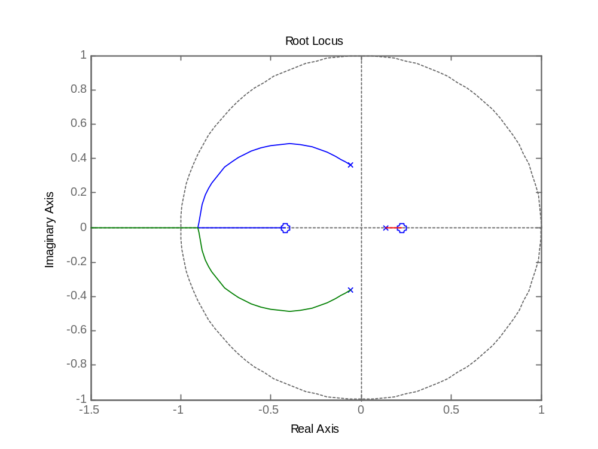
Transfer function:
0.8043 z^2 - 0.006927 z - 0.001777
-----------------------------------------
z^3 + 0.0545 z^2 + 0.006325 z - 4.54e-005

Sampling time: 5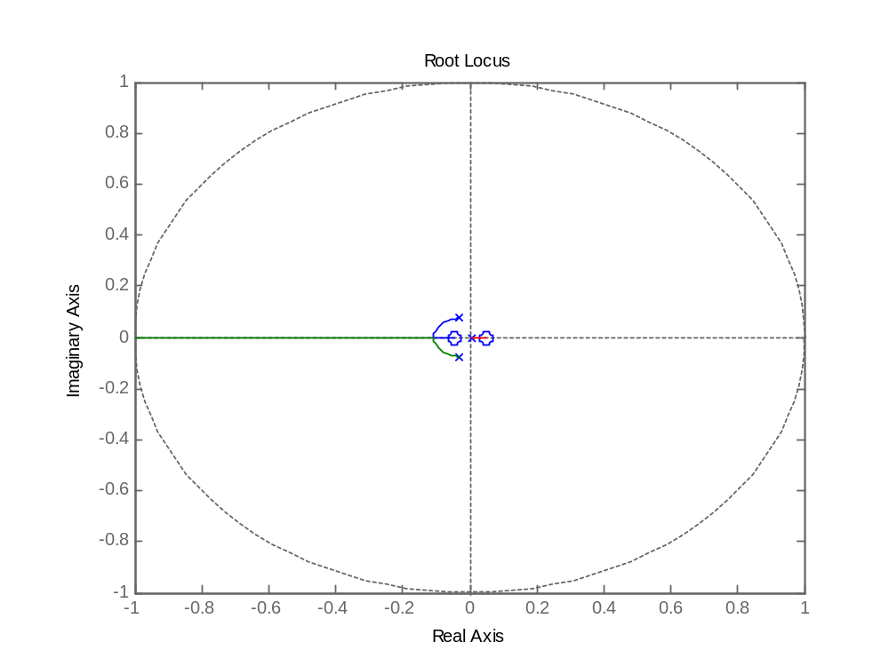

Transfer function:
0.7535 z^2 + 0.003778 z - 1.163e-005
---------------------------------------------
z^3 + 0.00968 z^2 + 4.496e-005 z - 2.061e-009

Sampling time: 10

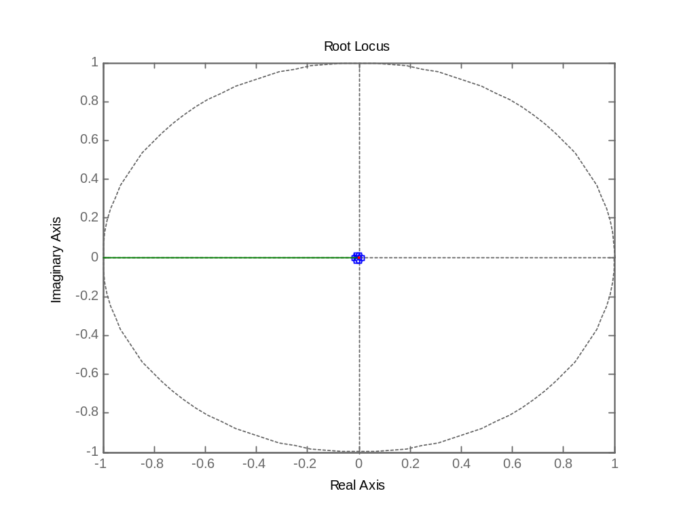

Transfer function:
0.75 z^2 - 7.445e-023 z - 9.3e-045
-----------------------------------------------
z^3 - 7.994e-023 z^2 + 3.72e-044 z - 4.848e-082

Sampling time: 100

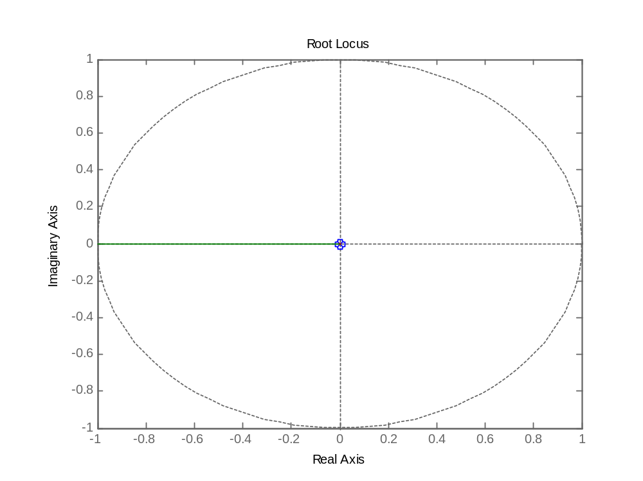

Punto c→
Transfer function:
s^3 + 10 s^2 + 10 s + 1
------------------------------
s^6 + 10 s^5 + 10 s^4 + 10 s^3

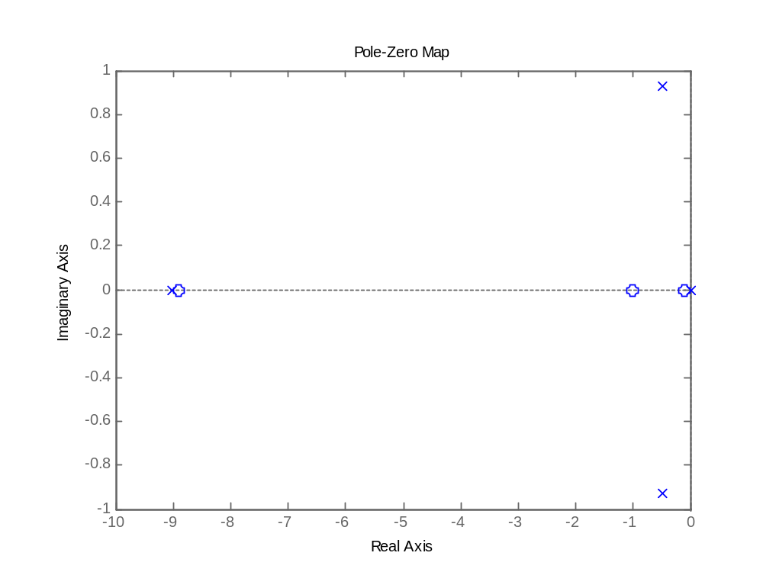

Transfer function:
0.1623 z^5 + 0.4226 z^4 - 0.5708 z^3 - 0.004948 z^2 + 0.05521 z - 1.364e-005
----------------------------------------------------------------------------
z^6 - 3.73 z^5 + 5.562 z^4 - 4.308 z^3 + 1.849 z^2 - 0.3732 z + 4.54e-005

Sampling time: 1
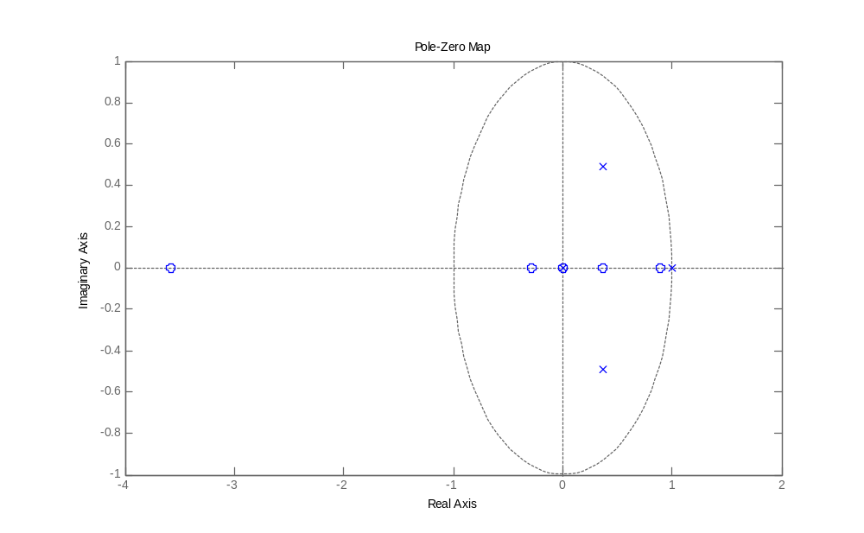
Transfer function:
2.083e-005 z^5 + 2.944e-005 z^4 - 0.000149 z^3 + 0.0001163 z^2 - 4.846e-006 z - 1.264e-005
------------------------------------------------------------------------------------------
z^6 - 5.586 z^5 + 12.95 z^4 - 15.95 z^3 + 10.99 z^2 - 4.013 z + 0.6065

Sampling time: 0.05
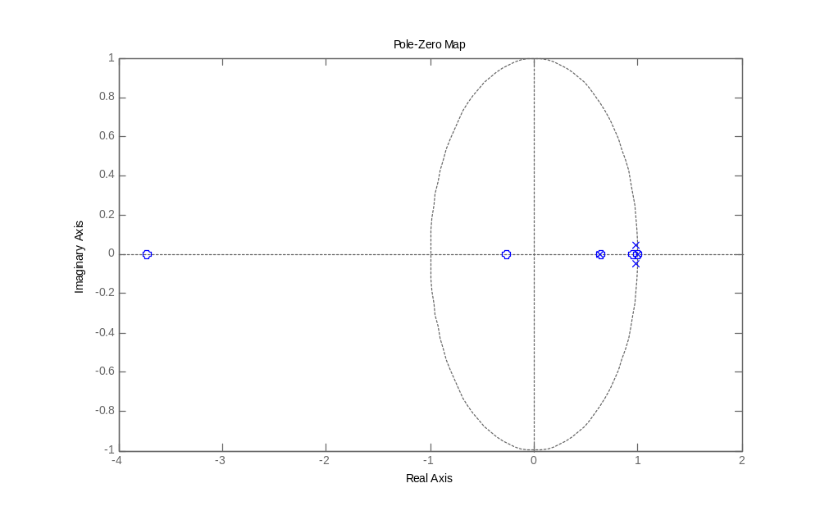
Transfer function:
1.667e-007 z^5 + 1.827e-007 z^4 - 1.301e-006 z^3 + 1.238e-006 z^2 - 1.351e-007 z - 1.508e-007
---------------------------------------------------------------------------------------------
z^6 - 5.904 z^5 + 14.52 z^4 - 19.04 z^3 + 14.04 z^2 - 5.523 z + 0.9048

Sampling time: 0.01
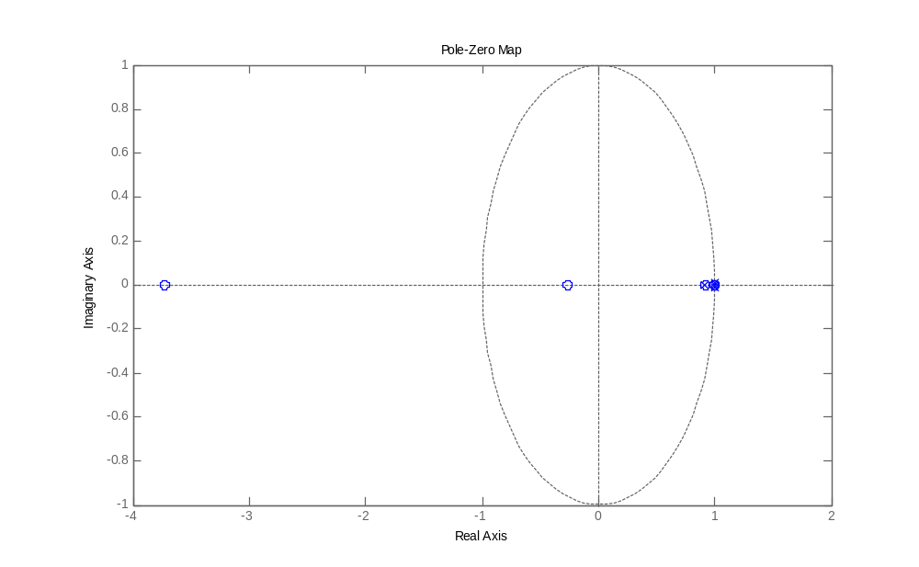

Punto2→

A)

Datos03
Modelos

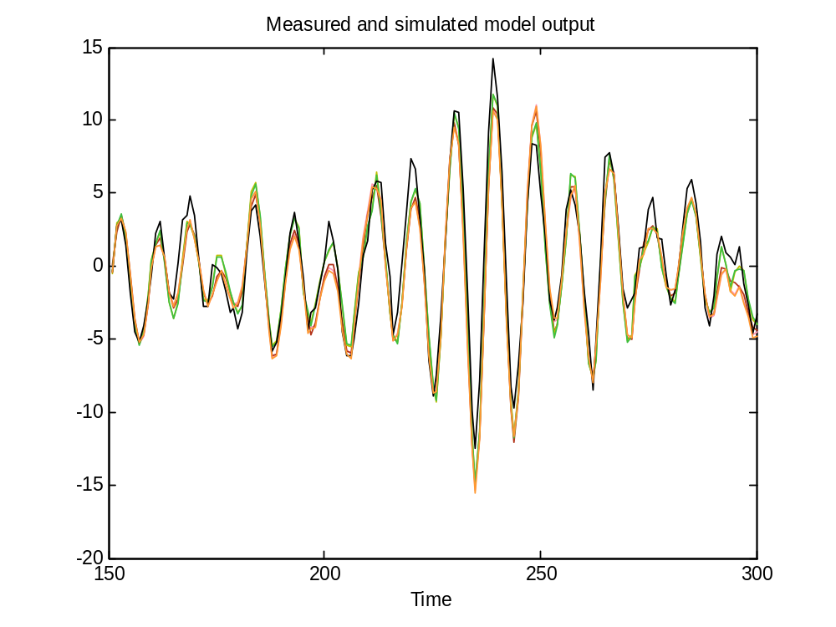
Arx 323
Discrete-time IDPOLY model: A(q)y(t) = B(q)u(t) + e(t)
A(q) = 1 - 0.8482 (+-0.08458) q^-1 + 0.0126 (+-0.09366) q^-2
- 0.0294 (+-0.07182) q^-3

B(q) = 0.9296 (+-0.09042) q^-3 + 0.137 (+-0.1179) q^-4

Transfer function:
6.048 s^2 - 6.55 s + 5.22
---------------------------------
s^3 + 3.527 s^2 + 6.015 s + 0.758

OE231

Discrete-time IDPOLY model: y(t) = [B(q)/F(q)]u(t) + e(t)
B(q) = -0.7207 (+-0.1247) q^-1 + 1.115 (+-0.1489) q^-2

F(q) = 1 - 1.323 (+-0.1453) q^-1 + 0.644 (+-0.2154) q^-2 - 0.2153 (
+-0.09132) q^-3

Transfer function:
1.718 s^2 - 2.633 s + 0.9
----------------------------------
s^3 + 1.536 s^2 + 1.884 s + 0.2413

ARmaX 3221
Discrete-time IDPOLY model: A(q)y(t) = B(q)u(t) + C(q)e(t)
A(q) = 1 - 1.719 (+-0.1618) q^-1 + 1.087 (+-0.2501) q^-2 - 0.3114 (
+-0.1103) q^-3

B(q) = -0.2321 (+-0.1149) q^-1 + 0.6344 (+-0.1486) q^-2

C(q) = 1 - 1.053 (+-0.1346) q^-1 + 0.3621 (+-0.1087) q^-2

Transfer function:
-0.8107 s + 0.6683
----------------------
s^2 + 1.016 s + 0.5135

ARX 123

Discrete-time IDPOLY model: A(q)y(t) = B(q)u(t) + e(t)
A(q) = 1 - 0.8511 (+-0.03568) q^-1

B(q) = 0.9177 (+-0.08078) q^-3 + 0.1126 (+-0.08934) q^-4

Transfer function:
-1.69 s + 2.381
----------------------
s^2 + 2.184 s + 0.6784

